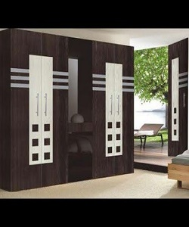

Cupboard

$210.45

Availability: In stock

Description

The ultra-modern Cupboard will transform an ordinary bedroom into the Centre of attention. This Cupboard also accommodates UK standard size. With its curvaceous contours and spacious glossy surface, the cupboard gives fashionable look to your room. The nature and design of this cupboard allows it to suit most modern bedrooms.